“The Room of Echoes”
A
Short Film Animation

A Capstone Project
Presented to the Faculty of the
College of Information Technology Education

PHINMA University of Iloilo

In Partial Fulfilment
Of the Requirements for the degree
Bachelor of Science in Information Technology
Group:
“Happy Kid”
Member:
John Patrick Gorembalem

April 2026

Approval Sheet
In partial fulfilment of the requirements for the Bachelor of Science in Information Technology, this Capstone Project entitled “The Room of Echoes” prepared and submitted by John Patrick Gorembalem. Who are hereby recommended for corresponding final evaluation.

Andrade, Jomanuel

Adviser

Approved by the Panel of Evaluators with a gde PASSED
Dr. Arnold M, Fuentes, Ph. D, MPA, MMIT
Chairman

Ryan Valeriano
Member

Accepted in partial fulfilment of the requirements of the
Degree Bachelor of Science in Information Technology

Seth dA. Nono, MSCS

CITE, DEAN

Acknowledgement

To my family, thank you for always being there for me, cheering me on, and believing in my abilities. Your love, guidance, and constant encouragement have given me the strength and motivation to overcome challenges and strive for excellence. Without your unwavering support, I would not be where I am today.

To my teachers, thank you for your dedication and passion for education. Your commitment to our learning journey has not gone unnoticed. You go above and beyond to ensure that we have the knowledge, skills, and resources we need to succeed. Your patience, creativity, and ability to inspire us have had a significant impact on my educational experience.
To my classmates and friends, thank you for being a part of my life. Your friendship and shared experiences have enriched my journey. Whether it was tackling group projects together or simply offering a listening ear during tough times, your presence and support have made all the difference.

Abstract

The Room of Echoes explores the inner landscape of a person’s mind and memories, where past experiences and emotions resonate like echoes. It symbolizes a journey of self-discovery,
confronting hidden fears, regrets, and joys, and ultimately finding acceptance and clarity.
In a timeless chamber shrouded in shadows, a solitary figure confronts the echoes of past whispers and childhood laughter, words of love and regret, fragments of identity scattered across a maze of doors. As memories unfold like luminescent doors in an endless corridor, they reveal the depths of joy, pain, hope, and fear that shape the soul.
Through the surreal journey, the figure learns that the room is both prison and sanctuary, a place to face the inner truths,
accept lost pieces and find strength in vulnerability. Emerging
From the echoes, he carries newfound clarity to understanding that within the labyrinth of memories lies the path to self-discovery and renewal.

TABLE OF CONTENTS
Title page --------------------------------------------------- i
Approval Sheet ---------------------------------------------- ii
Acknowledgement -------------------------------------------- iii
Abstract ---------------------------------------------------- iv Table of Contents ----------------------------------------- v-vi

CHAPTER I
Introduction ----------------------------------------------- p.7
Problem Statement ------------------------------------- p.8
Objective of the Study -------------------------------- p.8
Significance of the Study ----------------------------- p.9 Scope and Limitation --------------------------------- p.10

CHAPTER II
Related Literature --------------------------------------- p.11 References ----------------------------------------- p.12

CHAPTER III
Description -------------------------------------------- p.13
Research Methodology ---------------------------------- p.13
Qualitative Research--------------------------- p.13-14
Quantitative Research ---------------------------- p.14
Research Design ------------------------------- p.14-15
Data Collection Methods ------------------------- p.15
Data Analysis --------------------------------- p.15-16 Collection Methods ----------------------- p.17
Tools for Analysis --------------------------- p.18-20
Project Management ------------------------------ p.21
Tangible and Intangible Benefits ---------------- p.22
Proposed Budget --------------------------------- p.23
Return Of Investment ------------------------- p.24-25 Breakdown of ROI ------------------------------ p.25-2
CHAPTER IV

Animation Content -------------------------------------- p.27-29
Design and Genre of Animation --------------------- p.29-31
Description of Every Character -------------------- p.32-35
Layout Scenes ------------------------------------- p.35-38 Post-Production, Challenges, and Target Audience –---- p.38

CHAPTER V
Conclusion and Summary --------------------------------- p.39-40
Bibliography ---------------------------------------- p.41
Curriculum Vitae ------------------------------------- p.42 Grammarian Certificate -----------------

List of Tables
Table
2x2
Project Management

CHAPTER I

Introduction

In a world where inner landscapes shape our understanding of ourselves, this concept represents a journey of self-discovery, during which individuals confront their hidden fears, regrets, and joys stored within their memories. The Room of Echoes symbolize these memories as luminous doors, each revealing different aspects of individual past. These echoes include childhood laughter, words of love, and moments of pain that influence present identity.
The story begins within the confines of a small, windowless room that initially appears silent and empty, yet is filled with echoes of the past, including childhood laughter, expressions of love, and moments of regret. These memories are represented by glowing doors along a long corridor, symbolizing the deep history within every individual.
Through this surreal journey, the individual learns that life is both a prison and a sanctuary. It forces confrontation within inner truth, healing, and acceptance. The person gains insight into their true self, realizing that the labyrinth of memories holds the keys to renewal and growth. Ultimately, the story encourages engagement with one’s inner world as a path toward emotional healing and self-acceptance.

Problem Statement

This story aims to explore the relationship between an individual’s memories of their journey towards self-awareness and self-discovery, where they influence personal growth, and emotional stability. This story investigates how individuals confront the experience within their inner landscape and identify the challenges faced during the process of self-discovery, including feelings of vulnerability and resistance. Additionally, the story examines the role symbolic representations such as the Room of Echoes in facilitating emotional healing. It also seeks the person’s insight to gain true self and recognizes the importance of emotion and acceptance. Lastly, the story considers how this inner journey contributes to a person’s overall sense of acceptance and clarity.

Objective of the study

- 1.Studying relationship between an individual’s memories and their journey toward self-awareness
- 2.Investigate how hidden fears and joy influence personal growth and emotional stability
- 3.Exploring individuals confront and integrate experience within their inner landscape
- 4.Assessing the role of symbolic representations and facilitating emotional healing

Significance of the Study

This study’s focus is to explore the connection between memories and personal growth. “The Room of Echoes” serves as a powerful tool for facilitating acceptance through a meaningful story and fostering greater understanding, making it impactful for both creators and audiences.
For animators, the project demonstrates how to use animation more effectively to inspire and convey the importance of the story. For viewers, it offers a deeper understanding of the struggles and experiences portrayed, allowing them to gain moral lessons and insights from the project. In the end, this project contributes to a greater appreciation of personal growth, empathy, and the power of storytelling through animation

Scope and limitation of the Study

As the “The Room of Echoes” capstone project focuses on analyzing symbolic and emotional aspects related to personal growth, confronting fears and regrets, and joys through qualitative methods such as literary and thematic analysis. The study emphasizes the importance of inner reflection and emotional healing without focusing on technical interventions. It primarily targets understanding how symbolic representations facilitate self-discovery and emotional resilience.
Scope:
- 1.This study explores the inner memories and self-awareness presented in the story The Room of Echoes.
- It uses literary analysis to examine the emotional and symbolic aspects of personal growth.
- The study focuses on how individuals discover their inner selves and achieve emotional healing and clarity.
- It examines how storytelling and symbolism can encourage self-reflection and emotional understanding.
- The analysis focuses on the narrative elements and emotional themes presented in the animation.
Limitations:
- The interpretation of the story is subjective and may vary depending on the viewer’s personal experiences and emotions.
- The study focuses mainly on emotional awareness and self-reflection rather than providing psychological or clinical analysis.
- The research emphasizes storytelling and symbolism rather than technical animation analysis.
- The project focuses primarily on themes related to emotional and mental well-being.

Chapter II
Review of Related Literature
1.Artistic Styles & Storytelling Animation
According to Marie Bienvenu (2014), the expression and depiction of movement unite the emotions of body movements, gestures, and posture. This study emphasizes the concept of emotion and self-awareness. In animation, symbolic spaces like the Room of Echoes can represent the inner mind of a person and serve as a powerful tool for exploring personal identity and emotional growth.

2. Digital Storytelling
Research published by Mudalagi and Meeshi (2016) highlights the significance of digital storytelling in transforming the nature, structure, and reception of literary texts. According to this study, it enables creators to tailor the narrative to specific audiences and themes, thereby enhancing the emotional impact and resonance of the story.
3. Animation Development and Engagement
According to Peseira and Marcos (2025), they explored the intersection between traditional textile and digital innovation, proposing new approaches to textile art beyond traditional methods. By incorporating multisensory elements and interactivity, their findings highlight the opportunities for integrating emerging technologies into the artistic process, reinforcing the relevance of sensory engagement in the digital art context.

4. Animation as a tool for Value Education
Suleymanova, Kamola (2025), investigates the impact of technologies on the art of animation. The study covers the evolution from early hand-drawn animation to modern techniques. It emphasizes how animators contribute to new means of artistic expression, as well as the impact of technological advancements on animation quality.

References

Marie Bienvenu & Pascal Guehl (2024). Expressive Animation
Retiming from impulse Based Gestures. Motion, Interaction and
Games, Nov 2024, Arlington Va USA, Unites States pp. 1-7
ISSN: 04761328 v1
Mudalagi, Nirmala & Meeshi, Vijaykumar (2026). Digital
Storytelling and the Evolution of Literary Form. Journal
Research and Development. Pp. 78-79 ISSN:22309578
Selma Pereira, Aderito Fernandez-Marcos (2025). Reimagining traditions through artistic creation and immersive technologies. Pp. 19-37 ISSN:21848661
Kamola, Suleymannova (2025). Computer Animation on Visual Art.
Department of Sound Directing and Cinematography, pp.857-860
ISSN: 25824686

Chapter III

Research Description

This study explores the concept of the story as a symbolic space for self-discovery and emotional growth. Through a qualitative analysis of symbolic representations, the study examines how individuals process and integrate experience and emotions. The research aims to understand the potential environment in promoting self-awareness and emotional healing.

This study employs a multidisciplinary approach, drawing on literature, and art therapy to inform the analysis of the story. Through a close reading of symbolic representations, the research identifies key themes and patterns that emerge in the narrative. This study highlights the importance of confronting and integrating past experiences and emotion in achieving emotional healing and growth.

Research Methodology

This study employs a mixed-methods approach, combining qualitative and quantitative research techniques to gather and analyze data of The Room of Echoes.
Qualitative Research:
This study uses descriptive qualitative research to better understand animation and audience engagement. It also identifies gaps in these areas, guiding the development of effective research strategies and ensuring the effectiveness of this study. The methods include:

1. Content Analysis of existing animated works
Inspiring and effective animation captured utilize art styles, character design, and animation techniques, it will ensure the animation effectively and compelling narratives.

2. Narrative Analysis
Analyzing the structures and elements of animation to develop a personal understanding of how they can impact an individual's sense of experience, thereby helping to craft a compelling and engaging story that resonates with the audience.

3. Focus group with the target audience
Conduct discussion with other animators to gather insight of their perceptions, experience, and emotional responses related to the animation. Their feedback will help to make story more convincing.
Quantitative Research
The quantitative aspect of the research includes:

1. Comparison and Trends
Analyzing data over different participant groups to observe different perceptions of The Room of Echoes in terms of techniques, styles, story, and the impact of the story.

Research Design
As a proponent of the “The Room of Echoes” capstone project, the data gathering process was planned to determine the validity and reliability of the research. These methods ensure that effective and meaningful results are obtained. The key stages include:
- Pre- production: Concept development, scriptwriting, character design, and storyboarding.
- Production: Digital animation creation using software such as Krita for 2D animation and CapCut for editing.
- Post-production: Sound design, color correction, and final rendering.
- Audience Testing: We will evaluate panel’s reactions and refine the animation based on feedback.

Data Collection Methods
The data collection process includes:
1. Audience Feedback: Engage response and evaluating the satisfaction of the content presented.
Data Analysis
- Qualitative Data Analysis: Thematic Analysis of the feedback to identify the quality of the storytelling and gain insights into the audience's perceptions and engagement.
- Quantitative Data Analysis: Perform statistical analysis of the responses and provide valuable insights that establish overall perception and engagement levels.

Ethical Considerations
Ethical guidelines were strictly followed throughout the research process:
- Informed Consent: Participants were provided with comprehensive information about the purpose of the study and voluntarily agreed to participate.
- Privacy Protection: Participant’s personal data and responses were kept confidential and securely stored to ensure privacy.
- Fair Representation: Efforts were made to ensure that all participant groups were represented accurately and without bias, respecting diversity and inclusivity.
This research methodology used in The Room of Echoes aligns with the research objectives, allowing them to maintain the perception and interpretation of the room of echoes story. This study aims to provide valuable insights into the viewers to understand their thoughts and behaviors and engage the best outcomes of the story.
This research ensures that “The Room of Echoes”, will contribute meaningful understanding ang gain emotional growth.

Data Analysis
The data analysis process involved a systematic approach, using both qualitative and quantitative techniques.
- Qualitative Data Collection: Data gathered through interviews and feedback from other animators gains insights into participants’ perspective and experiences.
- Quantitative Data Collection: Statistical tools and software were used to identify the patterns or trends that measure correlations, differences, and relationships within the data. Results and Interpretation:
The result section objectively presented the data gathered through the project, providing narrative that accurately reflects the findings of the study. The interpretation of the results conducted rigorously, ensuring that the data determines significance and implications supported by analysis.
The selected mixed-methods approach was tragically aligned with research objectives of “The Room of Echoes” was facilitating a holistic exploration of the subject matter while ensuring qualitative depth and quantitative breadth in the findings. The ethical consideration imbedded within the data collection process safeguarded the integrity and credibility of the research, ultimately strengthening the robustness and insightfulness of the capstone project.

Collection Methods
As a proponent, I will outline the collection methods and tools for analysis in the context of digital animation. A comprehensive approach to data collection and analysis is crucial for gaining insights and understanding digital animation.
Collection Methods:
1.Story Boarding: Storyboarding is a visual planning process that involves creating a sequence of drawings or images to represent each scene or shot in a project. It helps animators and designers visualize the narrative flow, camera angles, and scene composition before production begins. This process serves as a blueprint for the creator, ensuring that the visual storytelling aligns with the intended narrative and technical requirements.
2.Digital asset creation: Involves designing and developing visual elements such as characters, backgrounds, objects and texture using Krita. This method relies on digital tools to craft detailed and reusable assets that can be integrated into various media projects.
3.Motion Capture: Motion Capture is a technique where actors wear suits equipped with sensors to record their movements, which are then translated into digital character animations. This method allows for realistic and natural motion data to be captured quickly and efficiently, especially for complex action.

Tools for Analysis:
- Animation Software: Animation software tools are used to create designs and animate characters and objects, enabling the development of smooth and realistic animations. These tools offer features that facilitate efficiency, especially for complex actions
- Frame by frame analysis tools: These specialized software programs are designed to examine individual animation, video, or motion footage. They allow animators to evaluate the timing, movement, and consistency of their work.
- Editing and Compositing software: Editing and composing software are essential tools for refining and enhancing video elements. They allow users to adjust colors, add effects, and improve overall visual quality. Software like CapCut provides an intuitive interface for organizing clips and creating cohesive stories. These editing processes make it easier to engage polished videos for different platforms.
- Animation playback and Review tools: This method guarantees the smooth flow of the story, allowing for detailed frame-by-frame inspection and makes it easy to identify errors or unnatural movements. These tools help ensure the animation is polished and meets the desired quality standards before final production.

Selection Process of Digital Tool
As a proponent of this project, the selection of Krita as the primary software was a strategic decision driven by its powerful features, user friendly interface, and suitability for creating detailed digital artwork. Krita’s extensive brush engine, versatility, and industry relevance made it the ideal choice for developing high quality visuals for “The Room of Echoes”. Its open-source nature also provided flexibility and cost effectiveness, ensuring that the creative process was seamless and efficient throughout the project.
Significance of Krita:
- Open Source and Free: Krita are completely free to use, making it accessible for students and professionals without any cost. This software provides flexible tools and features that cater to a wide range of artistic needs, allowing users to customize their workflow and create high-quality digital art efficiently.
- Versatility: Krita provides various art styles and features, such as comics, illustrations, and animations, that can enhance creativity and flexibility, making it accessible for users.
- Compatibility: Krita supports multiple operating systems and integrates well with other digital workflows and tools, ensuring flexibility and ease of use across different platforms.
Steps for Selection:
- Project Requirements Analysis: The initial phase involved a comprehensive assessment of the project’s needs. Since the “The Room of Echoes” use high quality 2D character and detailed backgrounds, the software chosen needs to support digital painting and detailed line work.
- Feature Assessment: Krita was evaluated based on its advanced brush customization, layer management, and support for detailed digital artwork. The availability of tools such as frame-by-frame animation and layers, along with its seamless integration with animation workflows, made it a strong candidate for artists seeking a comprehensive digital creation platform.
- Prototyping and Testing: Practical testing revealed Krita’s efficiency in producing detailed illustrations and handling complex artwork. Its intuitive interface, combined with features that facilitate a smooth creative process and high-quality output, contributed to its effectiveness.
4.Alighnment with project Objectives: Krita’s open source provides flexibility and effective production. Its comprehensive set of tools for digital painting and animation to produce high quality animation directly aligns with the goals of the project.
This capstone project, The Room of Echoes, was brought to life through combination of traditional storytelling methods and modern digital tools. Inspired by classic 2D animation, Krita was selected tools to use for its versatile animation features, which allowed to make expressive characters and backgrounds.

Project Management
1. Pre-production phase (2 Weeks) | Concept Development:  Brainstorm and finalize the storyline and visual style for The Room of Echoes. (2  Days)  Script Writing: Develop a detailed script outlining dialogue, actions, and scenes. (3 Days) Story Boarding: Create rough sketches of each scene, setting up composition and character placement. (4 Days) Character & Environment  Design: Design and finalize characters. (2 Weeks)
2. Production Phase (3 Weeks) | Background & Asset  Creation: Develop immersive  Room backgrounds. Props, and key visual elements. (1  Week)  Frame by Frame Animation:  Animate Characters and objects using krita for smooth 2D animation (5 weeks)
3. Post-production Phase (2 Weeks) | Sound & Music Integration:  Add sound effects, background music (1 Week)  Editing & Refinement:  Finalize animation, sync audio, and enhance visuals using CapCut. (1 Week)
4.Final Touches & Presentation  (1-3 Months) | Color Grading & Effects:  Adjust colors and add visual enhancements. (1  Week)  Final Review & Export:  Ensure quality control and prepare for final presentation. (2 Weeks)

Tangible and Intangible Benefits
- Skill Development: The Room of Echoes will help us improve our 2D animation skills with Krita and sharpen our editing and post-production techniques using CapCut.
- Portfolio Enhancement: The final project can be added to our portfolios, demonstrating our story telling, animation, and editing capabilities to future collaborations.
- Collaboration Opportunities: Working on this project provides a chance to collaborate with peers, voice actors, and sound industry connections.
- Audience Engagement: Sharing “The Room of Echoes” publicly increase our exposure, potentially attracting recognition from animation and storytelling communities.
Intangible Benefits:
- Creative Expression: The Room of Echoes will be enabled to bring unique artistic vision to life, experimenting with visuals, sound design, and storytelling techniques to create an immersive experience.
- Personal Growth: Overcoming technical and creative challenges throughout the project will help us develop resilience, improve our problem-solving skills, and boost our confidence in multimedia production.

Proposed Budget for The Room of Echoes
To promote The Room of Echoes, a simple marketing campaign was carried out. It focused on reaching the target audience through social media and community engagement. The proposed budget is shown below.
1. Pre-production Phase:
- Concept Development: Php 500
- Scriptwriting: Php 500
- Storyboarding: Php 500 • Character design: Php 1,000
2.Production Phase:
- Background Design: Php 1,000
- Editing (Frame-by-frame using Krita): Php 6000
3.Post-Production Phase:
- Sound Design: Php 1,000
- Editing (Using CapCut): Php 800
•
4.Final Touches and Presentation:
- Visual Effects: Php 600
- Color Grading: Php 1000
Total Estimated Budget: Php 12,900

The ROI (Return of Investment)
Target Audience:
Identifying the right audience helps maximize engagement and projects success of The Room of Echoes. The target audience includes:
- Animation Enthusiasts and Students - Educators and industry professionals seeking innovative examples of storytelling and animation techniques can benefit from analyzing the project's development, making it a valuable resource for both learning and inspiration.
- Content Creators and Artist - Artist and Storytelling enthusiasts might engage with the project by sharing their interpretations, creating fan art, or participating in discussions about its themes and artistic approach.

- Local community and Schools – Local community schools that enjoy watching imaginative stories in the animation industry and aim to gain valuable lessons about storytelling, creativity, and digital production techniques can make community engagement more fun and inspiring.

Marketing Strategy:
To effectively promote The Room of Echoes, the following strategies will be implemented.
- Content Marketing - Create engaging clips of animation can attract enthusiasts and students through social media platforms.
- Social Media Campaigns – Sharing the animation on social media platforms like Facebook and YouTube can attract enthusiasts, encourage engagement with the production, and inspire others to share.
Monetization and ROI Evaluation:
- Advertising - Increasing visibility, attracting target audience, and generating measurable returns on investment.
- Merchandise – Selling digital arts, posters, and animation related products.
- Audience Feedback – Evaluating effectiveness of advertising strategies, helping to attract additional support.

Breaking Down the ROI
To estimate the expenses and determine the time required to recover costs, we break and accrued expenses.

1. Fixed Expenses (Monthly Cost)
- Internet: Php 1000 per month
- Electricity: Php 600 per month

2.Variable Expenses (One-Time Production Costs):
- Animation production costs (backgrounds, character animation, effects): Php 9,500
- Sound design and Original Music: Php 1700
- Equipment and Software purchases (tablet, Krita software set up): Php 1500
3. Accrued Expenses (Additional Costs):
- Unexpected Expenses: Php 1,500
Total Expenses Calculation:
Fixed Expenses: Php 1,500 per month
Variable Expenses: Php 12,700
Accrued Expenses: Php 1,500
Total Expenses Formula: (1,500x3)+ 12,700+1,500= Php 18,700

Revenue Generation Strategies

1.Merchandise Sales:
- Estimated sales of posters, digital and animations assets: Php 7,000
2.Crowd funding & Donations:
- Target crowd funding goal: Php 3,000
3.Sponsorships & Collaborations:
- Expected sponsorships and partnerships deals: Php 2,000
4.Youtube Monetization:
- Estimated Revenue: Php 5,000

Total revenue Calculation: 7,000+3,000+2,000+5,000= Php 17,000
Time to Recover Expenses: 18,700/17,000= 1.1 Months

Chapter IV Animation Content
Synopsis:
In "The Room of Echoes," the story begins with a protagonist awakening in a mysterious, dimly lit room illuminated only by a flickering light. As they explore their surroundings, they notice a mirror across from them. When they investigate it, their reflection appears distorted, as if hiding secrets from their past, hinting at hidden truths waiting to be uncovered.
As the character gazes deeper into the mirror, they start to hear whispers—echoes of the past. These echoes swirl around their memories, conjuring fragments of childhood, moments of pain and joy, and encounters with lost loved ones. Each memory blurs the line between reality and imagination. The journey begins to become surreal as they delve into the depths of their mind and soul, forcing them to confront their fears, regrets, and hopes.
Throughout his journey, he understands that his past is a part of his identity, not something to be forgotten. The echoes serve as both a mirror and a guide, helping him confront fears and embrace his true self. As the journey progresses, the mirror shifts, reflecting clearer images and softer whispers, symbolizing acceptance. By the end, the echoes of the past carry a sense of peace, understanding, and self-compassion, reminding us that embracing our echoes is the path to true self-acceptance and freedom.

Title: The Room of Echoes
Overview:
"The Room of Echoes" is an animated story about a family or loved ones. The story follows the main plot points and narrative structure outlined below:
Act I: The Beginning
The story begins by introducing the main character, Jay. Jay is an only child, and when he was a child, his parents moved away to find work. Jay starts to have a determination to understand the life he has and is determined to accept his journey. However, he still imagines the love and joy of his parents' past, but he manages to overcome those challenges and start a new life.

Act II: The Journey
As his journey begins, Jay realizes his task is to accept the struggles he has, but when the mirror appears in front of him, he starts thinking about the past. Suddenly, reflections of his past pain and joy are shown, prompting him to confront his inner fears and embrace his true self to face the struggles he has.

Act III: The Climax
In The Room of Echoes, reaching the final story reveals that the true essence of life, Jay has strength and dedication. Through determination and realization, he overcomes meaningful obstacles, because of life's struggles and transforms into love, joy, and care, helping him to understand the true meaning and essence of life.

Act IV: The Resolution
Jay returned to his beautiful life and enjoyed all the moments of love and joy, concluding a heartwarming tale that reminds all that life is not just for fun, but that its true meaning lies in loving our family and ourselves.
Script:
JAY MEMORIES
-When the mirror started to flicker, memories began to enter, but Jay lacked the dedication to fight for them. He saw his parents—his mother singing for him and his father teaching him sports and bonding through those memories
-but suddenly those memories collapsed.
-Then he thinks that what if I fight for this dream and memories to overcome all the challenges.
-Mirror starting to flick again,
- Then Jay entered those memories, and all of them flooded into his mind, prompting him to consider fighting for them, and suddenly, the struggles in his mind transformed into joyful moments.
- Then, when it came to an end, Jay realized the true meaning of the essence of life and how to overcome those challenges.
Design and Genre of Animation
The art style for this story could be envisioned as a blend of surrealism and emotional realism, with surreal elements emphasizing the dreamlike, mysterious atmosphere of the room and the shifting echoes through distorted shapes, fluid lines, and symbolic imagery to evoke subconscious themes.
The project uses 2D digital animation, focusing on character movements to convey emotion and storytelling effectively.

Character Design
Jay
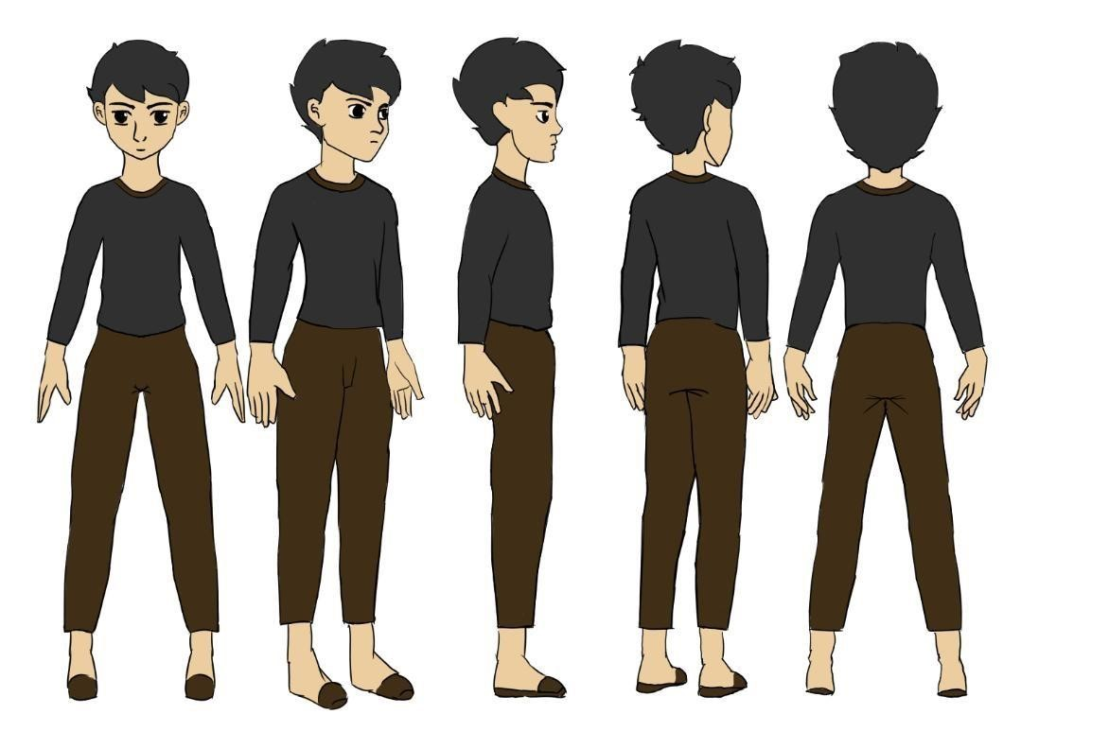
JAMES
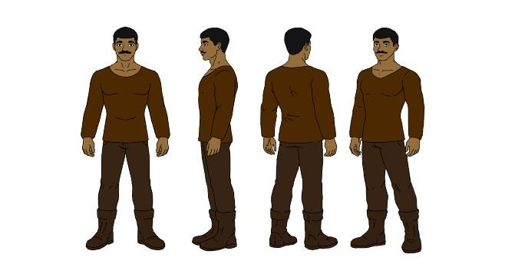

JUL
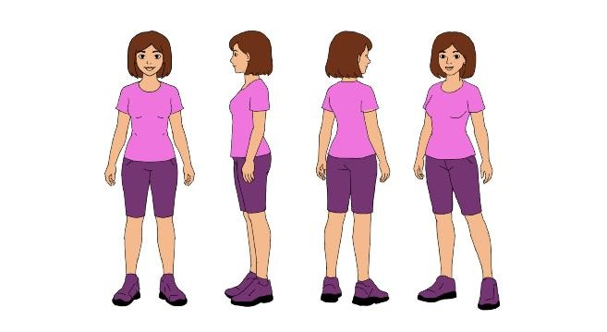

Expression of the character:
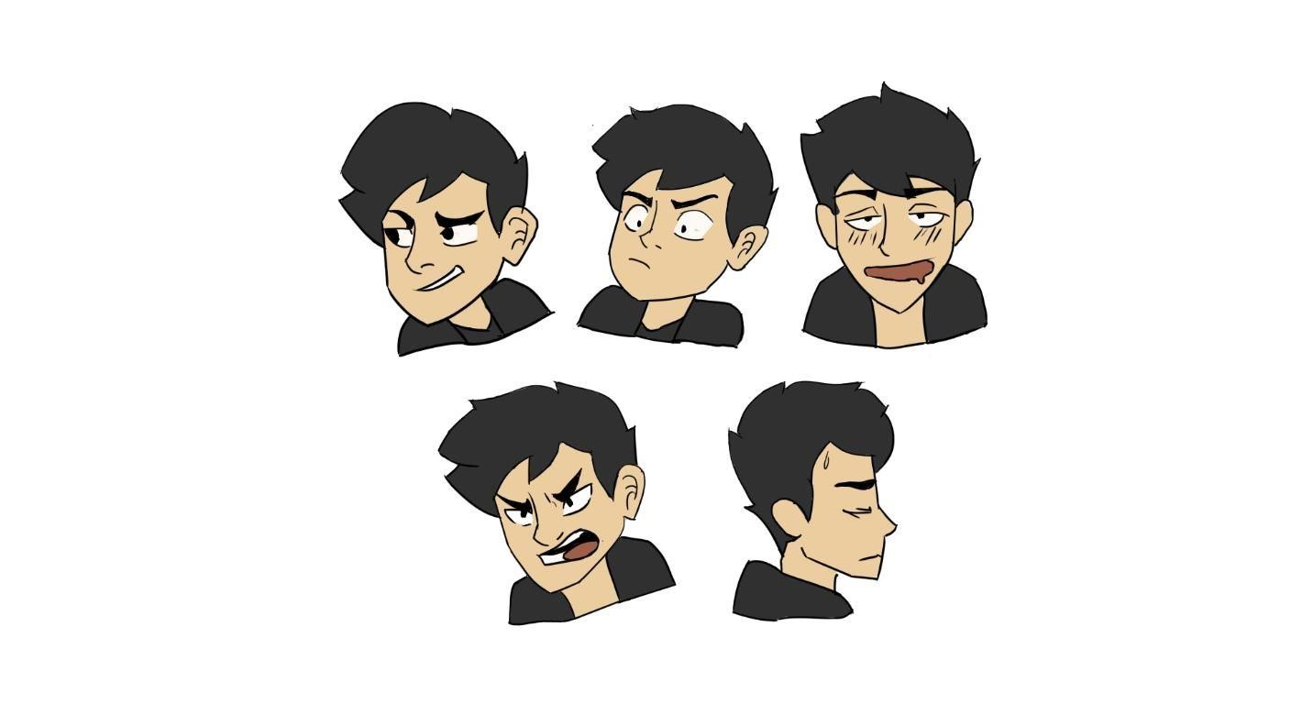

Description of every Character
JAY
Appearance:
Jay is a young child full of love, joy, and calm expression. He wears simple clothes to present a good appearance and has good intentions, with a loving and caring attitude. He is a son full of dreams, determined to fight the struggles he faces.
Background:
Jay grew up without his parents. He learned many things to overcome the challenges in his life and is determined to be a good person and to be independent.
Role in the Story:
Jay serves as a confronting person, possessing a strong mindset to face inner truths and accept pain to overcome life's struggles. He serves as a role model for others, inspiring them to become more resilient and compassionate.
Personal Traits: 1. Courage
2. Determination
3.Brave

JAMES
Appearance:
James is a man with a muscular body and dark skin tone, highlighting his strong and impressive appearance. He wears brown sleeves and dark pants, giving him a classic and timeless look that radiates confidence and style.
Background:
James is a dedicated father who balances strength and compassion in his daily life. He comes from a family with good values and the importance of providing a stable and loving environment for his son.
Role in the Story:
James plays the role of a strong yet caring father who embodies both resilience and tenderness. He is a guiding figure for his son, teaching him important life values such as honesty, respect, and perseverance. James's dedication to creating a stable and loving environment helps shape his son's character and confidence.
Personality Traits:
- Strength
- Compassion
- Dedication

JUL
Appearance:
Jul is a loving mother, caring and guiding her son to grow as a good person with determination in life, but then Jul goes far away to support the needs of her son and to build a better future for their family.
Background:
Jul is a dedicated mother who supports the needs of her family. She cherishes moments with her son. Jul is committed to her role as a mother, guiding her son with determination and love.
Role in the Story:
Jul plays the role of a strong woman. Despite being away from her son, she still managed to stay connected and support him in every way she can. Her resilience and love continue to inspire those around her. Personal Traits:
1 Loving
2.Compassion
3. Determination

In “The Room of Echoes” the staging and composition choices are important in enhancing the storytelling and visual appeal of the animation. Here are some key considerations:
- Staging: Scene carefully composed, character placement and camera angles. Clear layout helps the story focus on the key moments.
- Composition: Layouts and balance of color and contrast, emphasize the moments and mood of the story.
- Timing & Rhythm: The pacing of movements and scene transitions are deliberate, clear, and impactful.
- Exaggeration: Action, expression and camera movements making key moments stand out and ensuring the story flows smoothly
- Appeal: Characters, backgrounds, and motion are infused with personality through simple design and chosen colors, it will make the story livelier and more relatable.

Layout Scenes
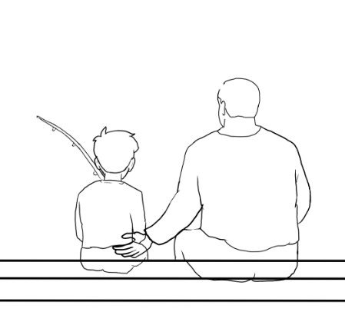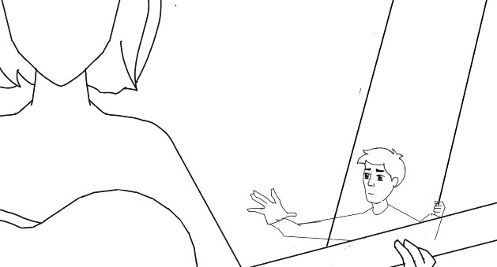

Camera Angles
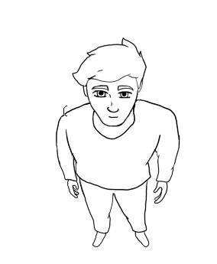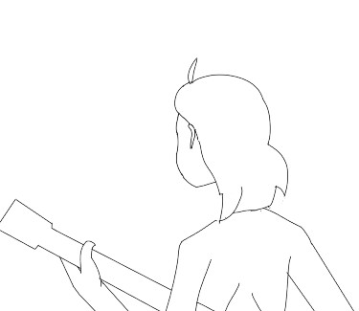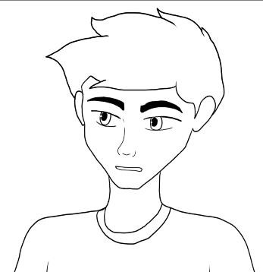

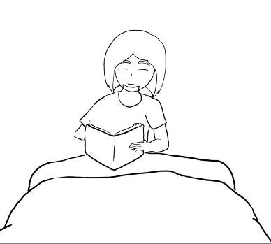
Layout Scenes
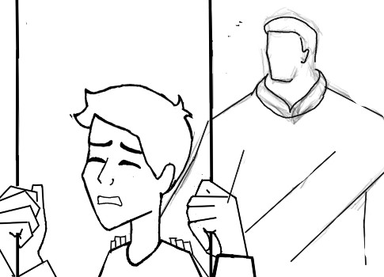

In Between
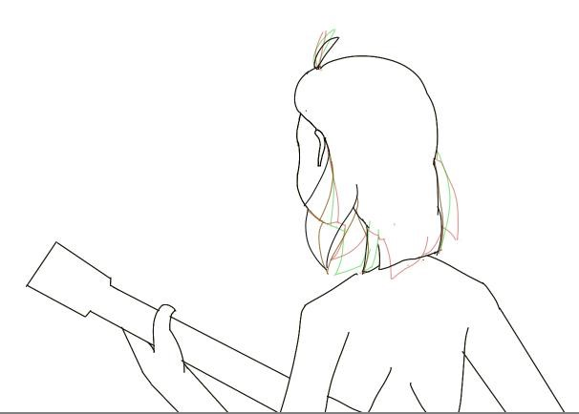

Story Board
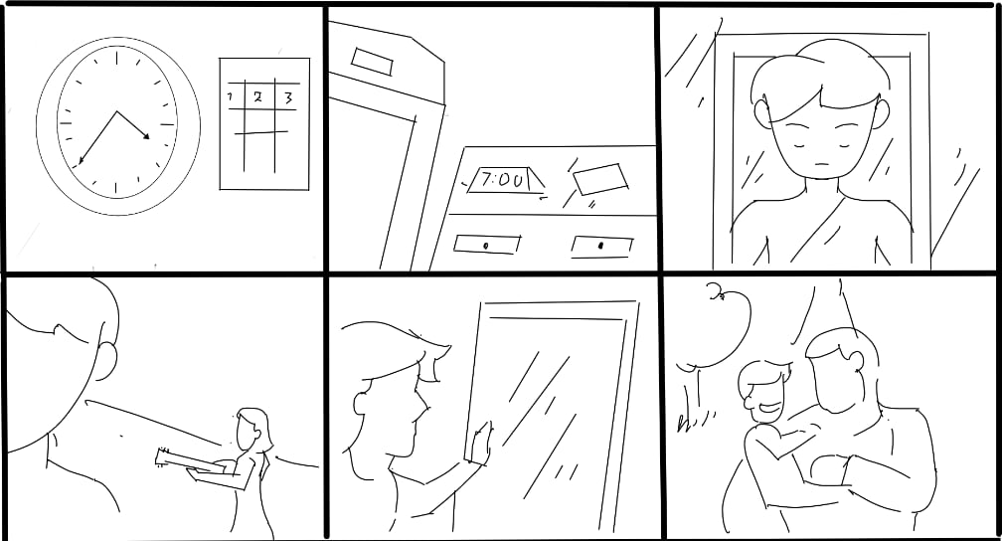
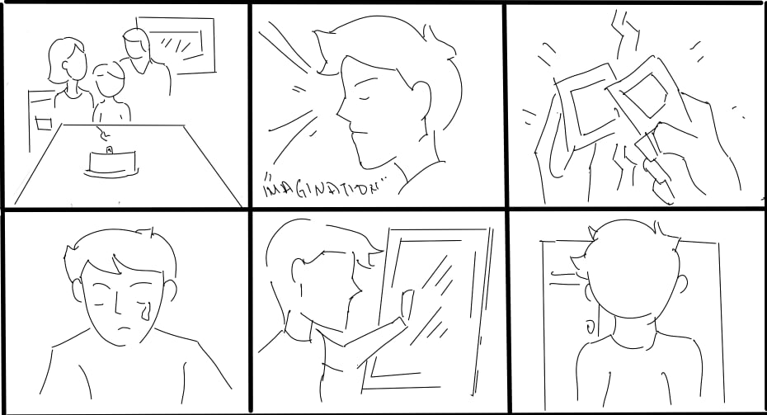

Backgrounds Scenes
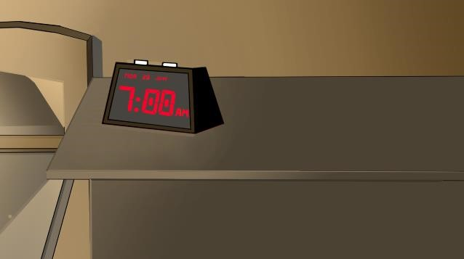

- Sound Design
The Room of Echoes uses soft music and effects to maintain calmness of the story.
- Post-Production
Editing, color grading, and sound applied to ensure the smooth transition create a seamless and engaging viewing experience.
3.Production Challenges
Animation consistency and managing scene flows and effects are challenges overcome through determination and continuous learning from others' perspectives and ideas to complete the project successfully.
4. Target Audience
The target audience are young children, the animation’s calmness, story, and moral lessons make it more inspiring and suitable for their age.

Chapter V
Conclusion:
In conclusion, The Room of Echoes portrays an inspiring story and demonstrates determination to overcome challenges. Through Jay's journey, it gives valuable insight into resilience, self-discovery, and the importance of perseverance. It reminds audiences that the true meaning of essence of life comes from hard work, determination and having the strength to fight those challenges in life.

This project demonstrates how animation relates to personal growth, confronting fears, and overcoming regrets. This story emphasizes the importance of inner reflection and emotional healing without delving into unnecessary details, allowing viewers to connect deeply with the protagonist's journey.

Summary:
In The Room of Echoes, the story is set in a surreal space where memories, identity, and self-discovery are intertwined. The protagonist encounters a distorted reflection in the mirror, which acts as a gateway to fragmented moments from their past. Through this surreal journey, they confront hidden truths and long-forgotten emotions, ultimately learning that accepting their echoes is key to understanding their true self.
The story begins with a quiet, almost haunting atmosphere, where whispers from childhood and shadows fill the room. As the protagonist gazes into the mirror, they see vivid scenes of family and joy, revealing how deeply their history shapes their present. This moment of reflection creates a tension between the familiar and the unsettling, hinting at a deeper self-awaiting discovery.
By facing the mirror and its echoes, the protagonist finds a sense of peace, understanding that embracing both pain and happiness from their past is vital for growth. The story emphasizes that self-acceptance involves acknowledging all parts of oneself, including memories that may be uncomfortable. Ultimately, the journey through echoes becomes a path toward clarity, acceptance, and inner harmony.

Bibliography:

Helmuth, Reiter (2012). Interactive digital technologies on scene-consequences and perspective on aesthetics of performative spaces. Faculty of Technical Science, University. (2012) pp.6071 ISSN: 05223851 v1
Amira Chalbi (2018). Understanding and designing animations in the user interfaces. University, de Lille, Human-Computer Interaction ISSN: 01881889v
Kamola, Suleymanova (2022). Multidisciplinary journal of Science and Technology. Computer Animation Development on Visual arts.
Department of Cinematography pp 857-860 ISSN: 25824686
Fernandes-Marcos, A., & Pereira, S. (2022). Post-digital textile aesthetics: A critical reflection on the process of digital rematerialization of artefacts. In ARTeFACTo – Third International
Conference on Digital Creation in Arts, Media and Technology
(pp.1-9). Macao ISBN: 979-8-3503-1004-7
Marie Bienvenu & Pascal Guehl (2024). Expressive Animation
Retiming from impulse Based Gestures. Motion, Interaction and
Games, Nov 2024, Arlington Va USA, Unites States pp. 1-7
ISSN: 04761328 v1
Mudalagi, Nirmala & Meeshi, Vijaykumar (2026). Digital
Storytelling and the Evolution of Literary Form. Journal
Research and Development. Pp. 78-79 ISSN:22309578
Selma Pereira, Aderito Fernandez-Marcos (2025). Reimagining traditions through artistic creation and immersive technologies. Pp. 19-37 ISSN:21848661
Kamola, Suleymannova (2025). Computer Animation on Visual Art.
Department of Sound Directing and Cinematography, pp.857-860
ISSN: 25824686



